
Lab Report


STUDENT DETAILS
Name: Muhammad Ismail
Reg.no: SU-24-01-001-054
Semester/Program/Section: 3rd,BS CS-02
Department: CS & IT
Subject: Data Structures and Algorithms (DSA)
Date: 27-02-2026
Submitted to: Sir Mr. Niamat Ullah
Week #1
Lab Task #1:
Variables & Input(cin)/Output(cout) Collect Student Information and Display It Instructions:
- Create a new C++ file named: task1_variables.cpp
- Declare variables to store: o name (string) o age (int) o gpa (float or double)
- Ask the user to enter all three values.
- Display the stored information in a clear formatted manner.
Program:
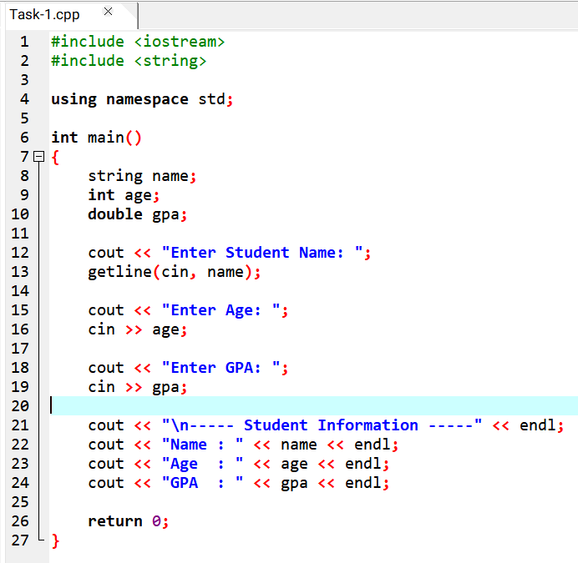
Program Output:

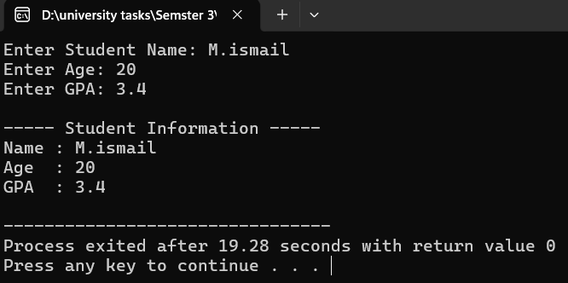
Lab Task #2:
Control Flow (if/else and loops) Check if a number is even or odd + print counting until that number Instructions:
- Create a file: task2_controlflow.cpp
- Ask the user to input a number.
- Use if / else to check: o If the number is even → print "EVEN" o Else → print "ODD"
- After showing even/odd, use a for loop to print counting from 1 to that number.
Program:
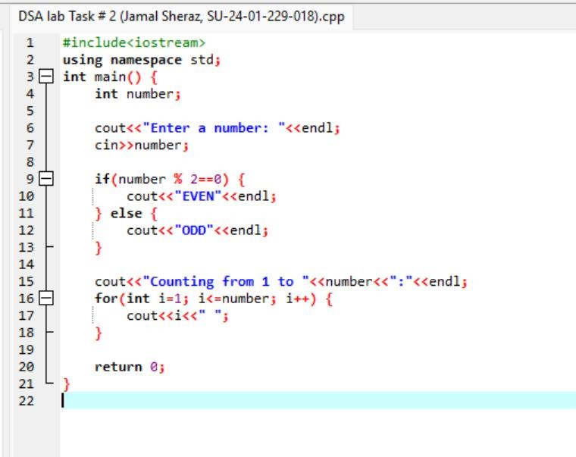
Program Output:
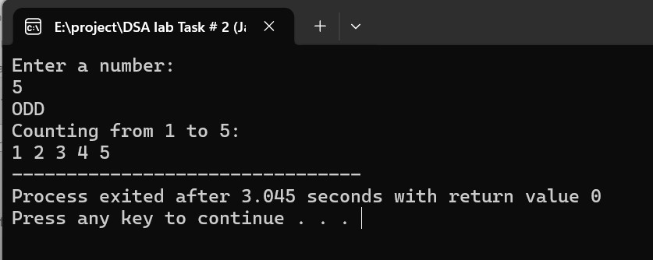
Lab Task #3:
Task #3: Simple Calculator Using Functions (C++) Write a C++ program that behaves like a simple calculator using functions.
- Ask the user to enter two numbers.
- Display an operation menu: 1. Add 2. Subtract
- Multiply 4. Divide 3. The user will choose one operation (1–4).
- Based on user choice, call the corresponding function.

Program:

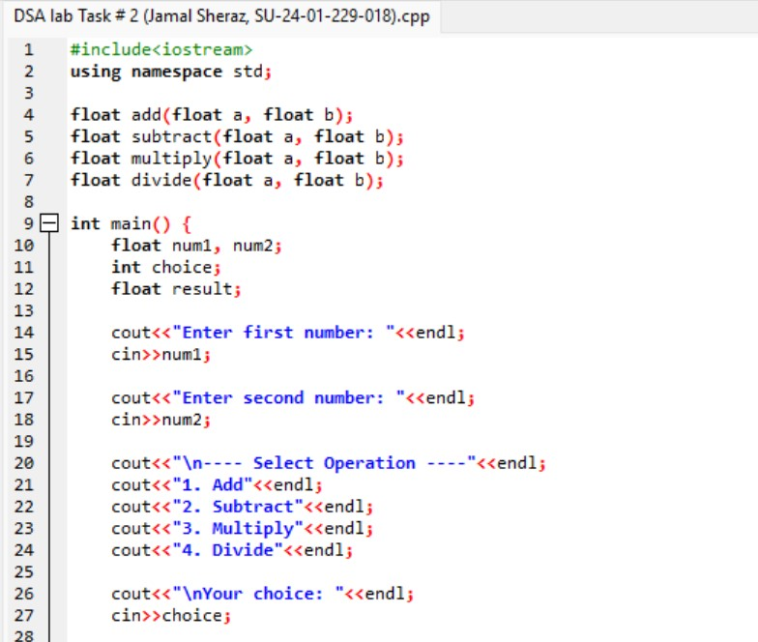

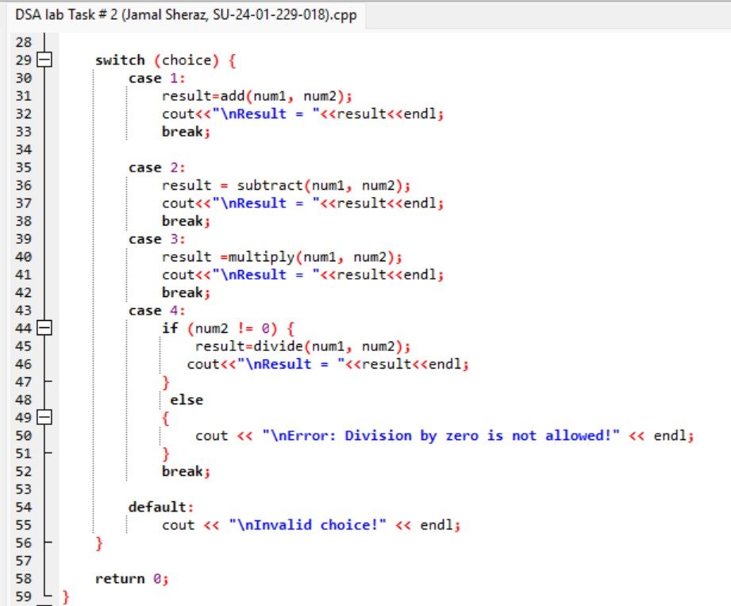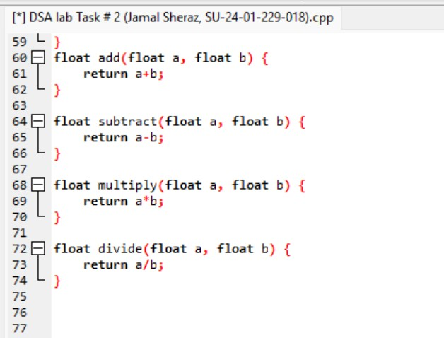

Program Output:

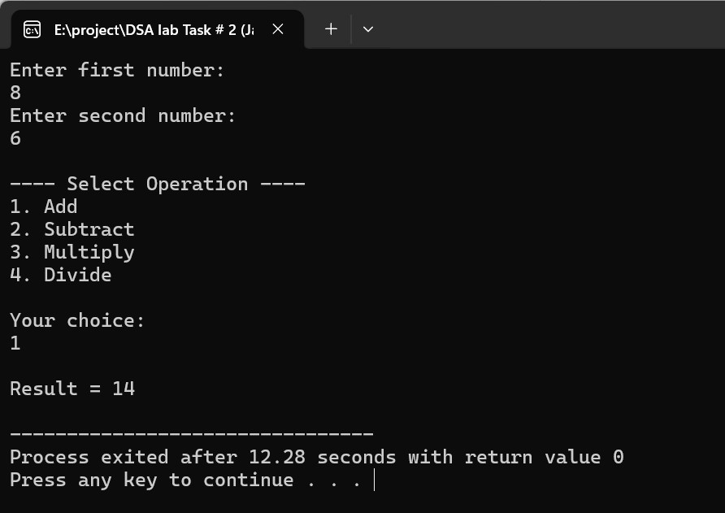

Lab Task #4:
OOP (Class & Object) – Book Management Create a C++ program using classes and objects to manage information about a book. Requirements
- Create a class named Book.
- Inside the class, include the following data members: o title (string) o author (string) o price (float)
- Add member functions: o inputData() → to take user input for all attributes o displayData() → to print book information o applyDiscount() → takes discount percentage from user, reduces the book price accordingly

Program:
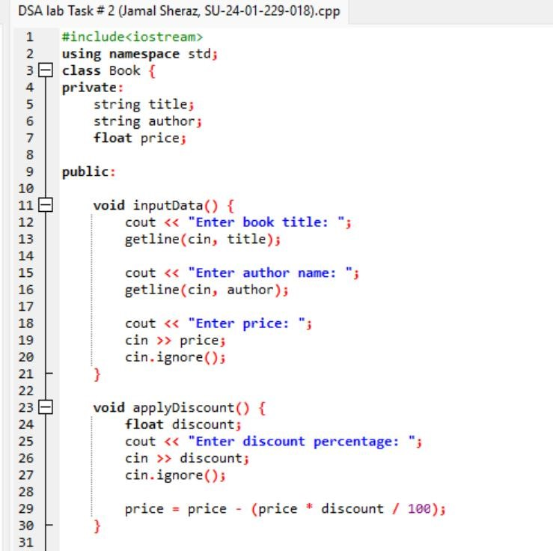
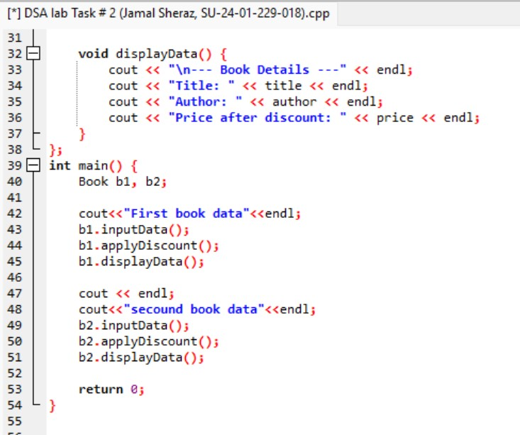

Program Output:

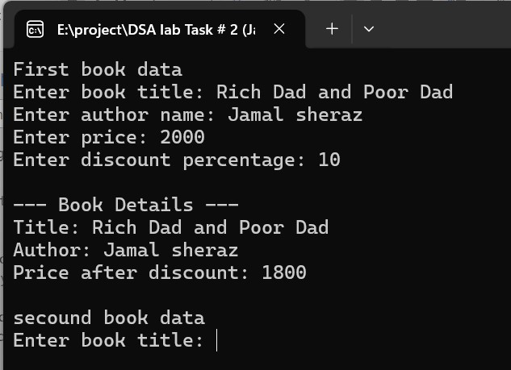

Lab Task #5:
Linear Search with Student Marks
Objective Write a C++ program to find a student’s marks in a class using Linear Search.
Dataset (Array) int marks[10] = {78, 85, 92, 67, 55, 88, 73, 60, 95, 81};

Program:
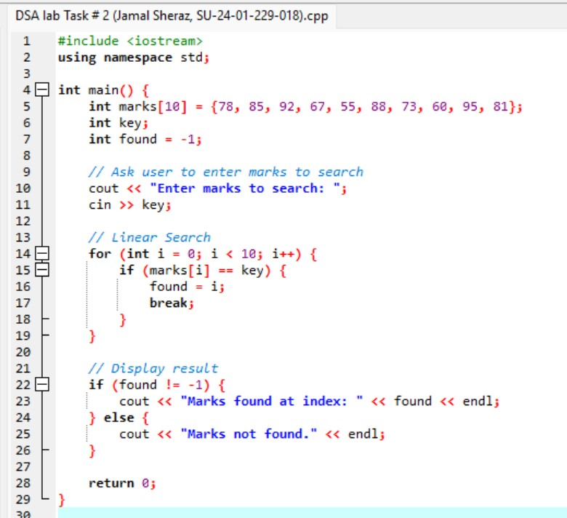
Program Output:
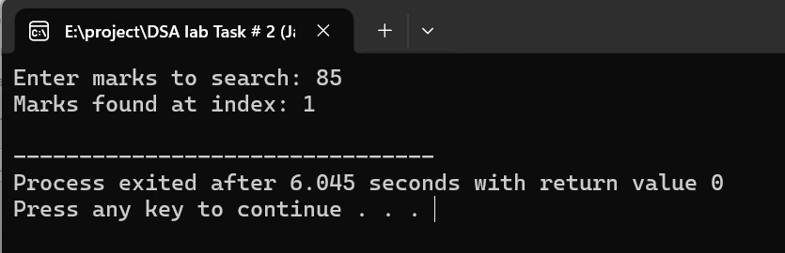

Lab Task #6:
Binary Search with Product Prices
Objective Write a C++ program to find the position of a product price in a sorted array using Binary Search.
Dataset (Sorted Array) int prices[10] = {50, 75, 120, 150, 200, 250, 300, 350, 400, 500};
Program:
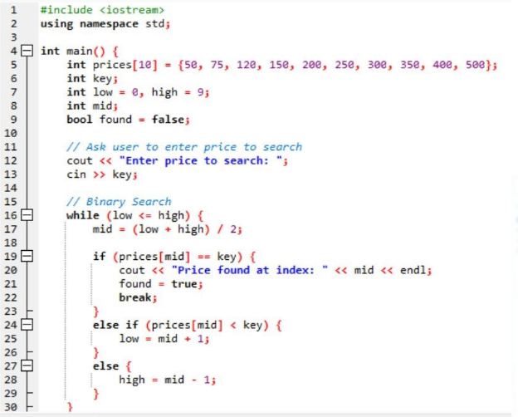
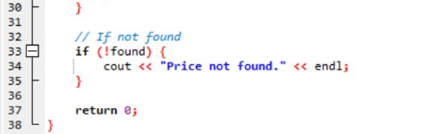

Program Output:
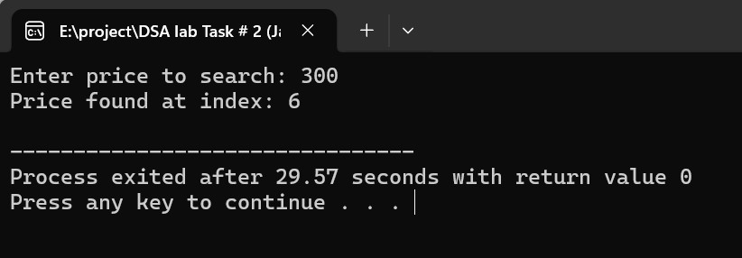

Week: 2

Lab Task: 1
Problem Description:
In many student management systems, basic student information needs to be stored and displayed in a readable format.
This lab task requires creating a C++ program that uses string variables to store student details.
The program should allow the user to enter the student’s name, roll number, course, and grade. After taking the input, the program will display the information in a formatted structure.
Additionally, the program will perform simple string operations such as finding the length of the student’s name and concatenating all the student details into a single string for display.
This task helps students understand how strings work in C++ and how they can be used in real-world programs for storing textual data.
PROGRAM SCREENSHOT:
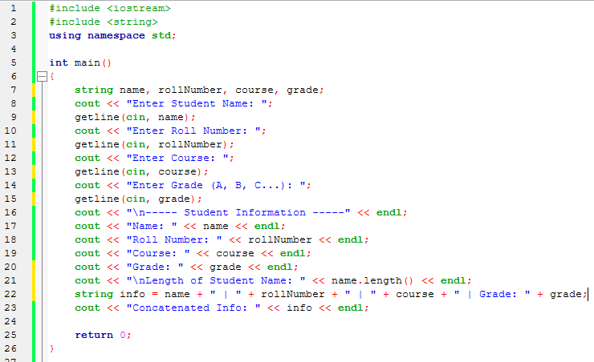

PROGRAM OUTPUT SCREENSHOT:
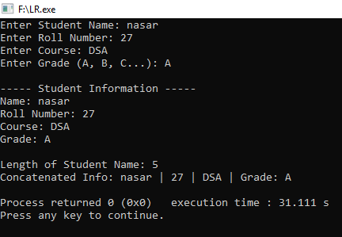

Lab Task: 2
Problem Description:
In programming, functions are used to divide a program into smaller and manageable parts. Each function performs a specific task.
In this lab task, students will develop a simple calculator program using functions in C++. The program will ask the user to enter two numbers. Then separate functions will be created to perform addition, subtraction, multiplication, and division.
Each function will take the numbers as input, perform the required operation, and return the result. Finally, the program will display the results of all operations to the user.
This task helps students understand the concept of function definition, function calling, parameters, and return values in C++.

PROGRAM SCREENSHOT:
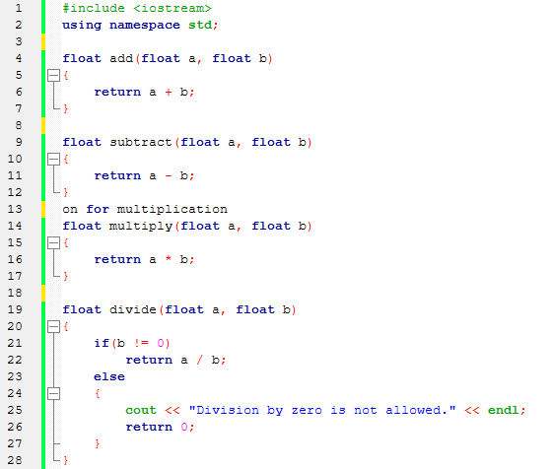
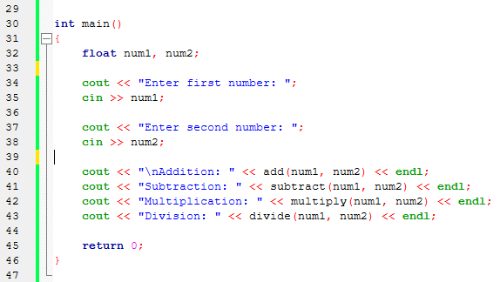
PROGRAM OUTPUT SCREENSHOT:
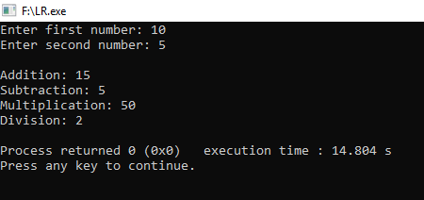

Lab Task: 3
Problem Description:
Pointers are an important concept in C++ that allow programs to work directly with memory addresses.

They are widely used in advanced programming topics such as data structures, dynamic memory allocation, and efficient data manipulation.
In this lab task, the program will declare two integer variables a and b. Two pointer variables will then be created to store the addresses of these integers.
The program will display the addresses and values of both variables using pointers. After that, the values of a and b will be swapped using pointers. Finally, the program will display the new swapped values of the variables.
This exercise helps students understand pointer declaration, dereferencing (*), and how pointers can modify original variable values.

PROGRAM SCREENSHOT:

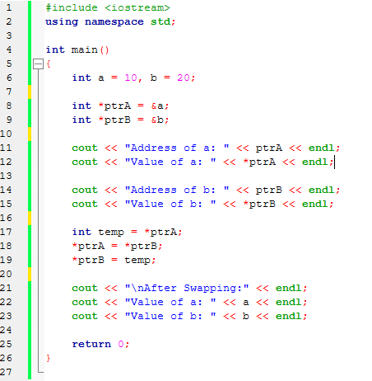
PROGRAM OUTPUT SCREENSHOT:
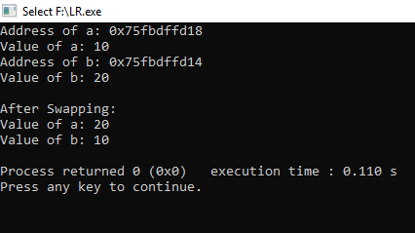

Lab Task: 4
Problem Description:
In many organizations, employee information such as ID, name, and salary needs to be stored and managed efficiently. C++ provides a feature called structure (struct) that allows grouping different types of data into a single unit.
In this lab task, a structure named Employee will be created with three members: empID, name, and salary. The program will ask the user how many employees they want to enter and then use a loop to input the details for each employee.
After collecting the data, the program will display all employee records. It will also filter the records and display only those employees whose salary is greater than 50,000.
This task helps students understand structures, arrays of structures, loops, and conditional statements in C++.

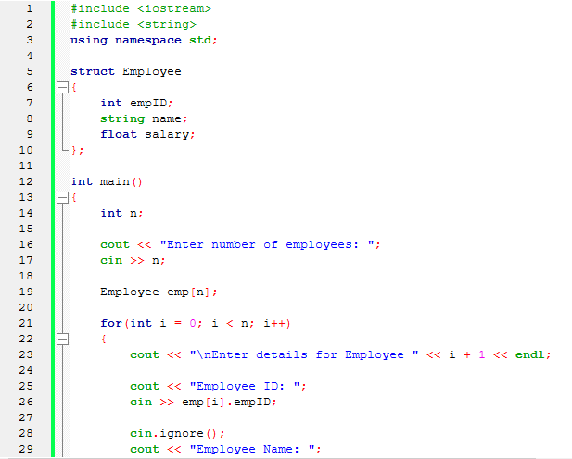
PROGRAM SCREENSHOT:

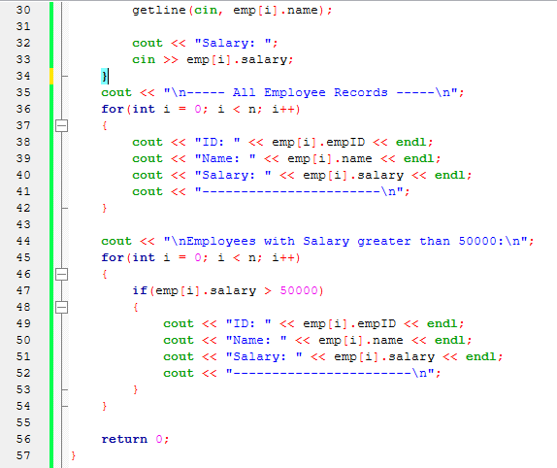

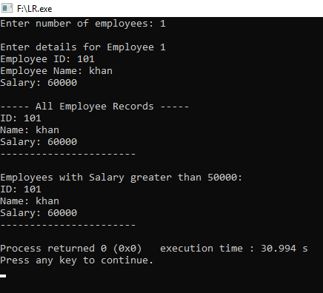
PROGRAM OUTPUT SCREENSHOT:

Week: 3
Task: 1
Problem Description:
Arrays are used in programming to store multiple values of the same data type in a single variable. Instead of declaring many separate variables, an array allows storing values in indexed positions.
In this task, students will declare three different one-dimensional arrays with specific data types and sizes.
The arrays include an integer array named positive Numbers, a character array named vowels, and a floating-point array named temperatures.
After declaring each array, the program should display a confirmation message indicating that the array has been successfully declared. This task helps students practice array declaration syntax and basic output statements in C++.

PROGRAM SCREENSHOT:
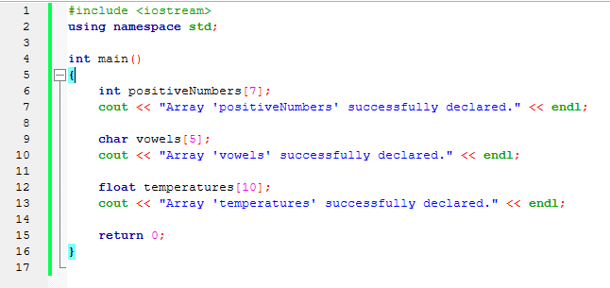
PROGRAM OUTPUT SCREENSHOT:
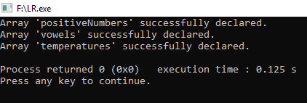

Task: 2
Problem Description:
In C++, arrays can be declared and initialized simultaneously. Initializing arrays helps in assigning known values before performing any operations.
In this task, students will:
- Declare an integer array positive Numbers of size 5 and initialize it with positive integers.
- Declare an integer array negative Numbers of size 4 and initialize it with negative integers.
- Declare an integer array random Numbers of size 8 and initialize it with any integers (both positive and negative, including zero).
After initialization, the arrays are ready to use for further operations in programs. This task also helps students practice array syntax, initialization, and memory allocation in C++.

PROGRAM SCREENSHOT:
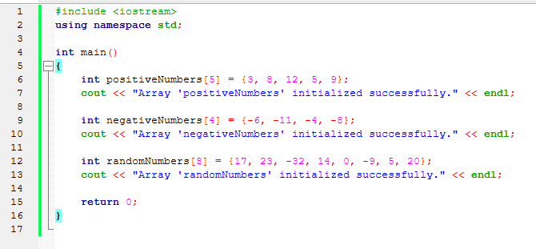

PROGRAM OUTPUT SCREENSHOT:
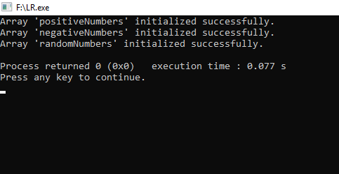

Task:3
Problem Description:
Arrays allow storing multiple values of the same data type in contiguous memory locations. Usually, loops are used to input or display array elements.
In this task, students will declare an integer array named ages with a size of 5. The program will then store the ages of five individuals directly by assigning values to each index.
Finally, the program will access and print each element individually without using any loop. This helps students understand array indexing, element assignment, and access syntax in C++.

PROGRAM SCREENSHOT:
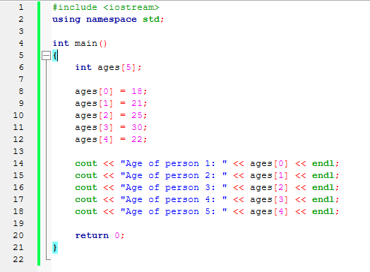

PROGRAM OUTPUT SCREENSHOT:
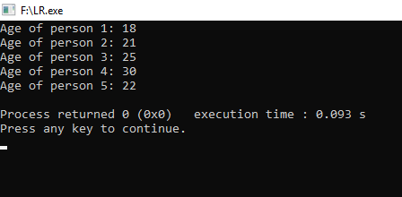

Task: 4
Problem Description:
Arrays in C++ allow storing multiple values of the same data type in contiguous memory locations. While loops are often used to input and access array elements, sometimes values are assigned and accessed manually using indices.
In this task, students will declare an integer array named scores with a size of 4. The program will store values 10, 20, 30, and 40 directly into the array elements without using a loop. Then, each element will be accessed and printed individually. This task reinforces understanding of array indexing, assignment, and output.

PROGRAM SCREENSHOT:
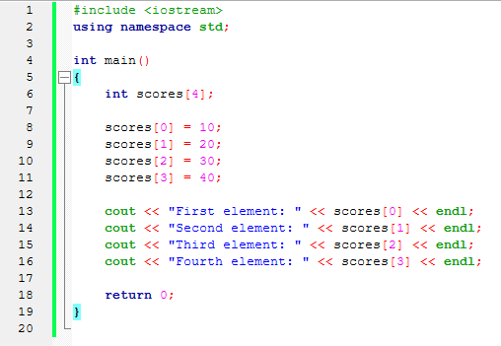

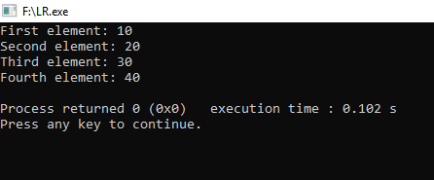
PROGRAM OUTPUT SCREENSHOT:

Task: 5
Problem Description:
Arrays allow storing multiple values of the same type in a single variable. Managing arrays often involves traversing, counting specific elements, and reversing them.
In this lab task, students will:
- Declare an integer array of size n, where n is input by the user.
- Input n elements into the array.
- Traverse and display all elements.
- Count and display the number of even and odd elements.
- Reverse the array and display the reversed array.
This task helps students practice loops, array indexing, conditional statements, and array manipulation techniques in C++.

PROGRAM SCREENSHOT:
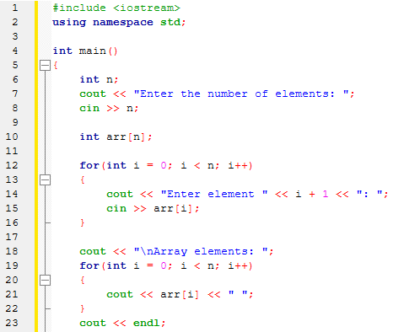

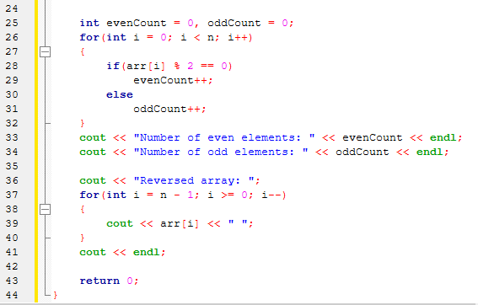

PROGRAM OUTPUT SCREENSHOT:
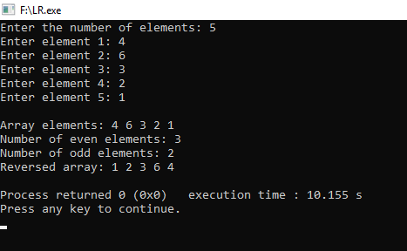

Task: 6
Problem Description:
A matrix is a two-dimensional array that stores data in rows and columns. Many real-world applications like spreadsheets, image processing, and scientific calculations use matrices.
In this lab task, students will:
- Input the number of rows r and columns c.
- Declare a 2D array of size r × c.
- Input elements for the matrix.
- Display the matrix row-wise.
- Calculate and display the sum of each row.
- Calculate and display the sum of each column.
- Find and display the largest element in the matrix.
This task helps students understand nested loops, array traversal, and basic matrix operations in C++.
PROGRAM SCREENSHOT:
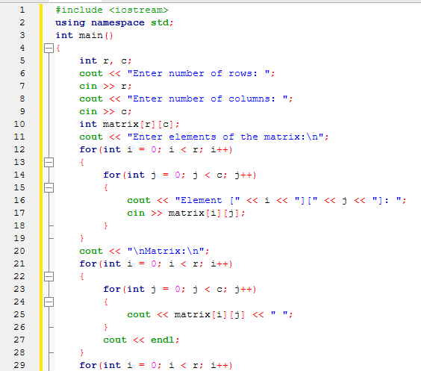

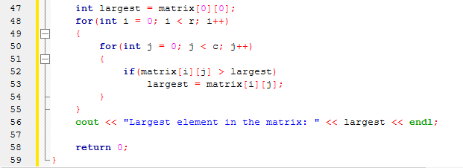
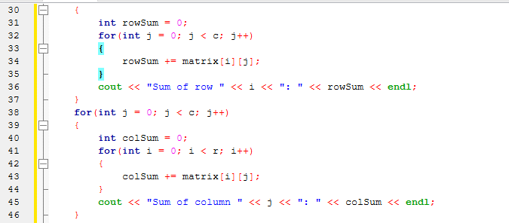

PROGRAM OUTPUT SCREENSHOT:
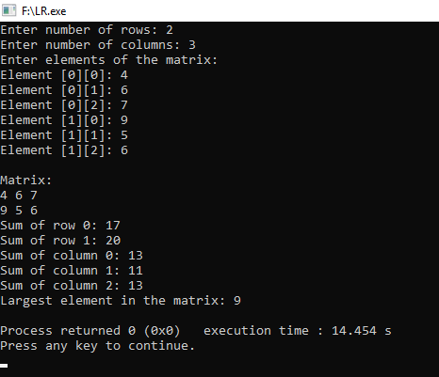

Week: 4
Task: 1
Problem Description:
Arrays allow storing multiple values of the same type in a single variable. In this task, a temperature array for a week is given. The program will:
- Traverse the array and display each temperature.
- Calculate the sum of all temperatures.
- Compute the average temperature and display it.
This helps students practice array declaration, initialization, traversal using loops, and basic arithmetic operations in C++.

PROGRAM SCREENSHOT:
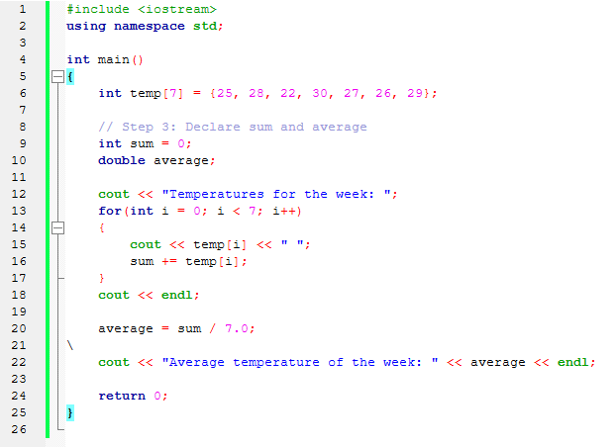

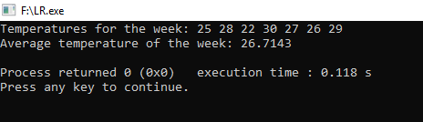
PROGRAM OUTPUT SCREENSHOT:

Task: 2
Problem Description:
Arrays in C++ have fixed sizes, but we can insert elements by shifting existing elements manually.
In this task:
- An array sales[10] is initialized with 5 elements representing daily sales.
- Insert a new sale at the end of the array.
- Insert a new sale at the beginning, requiring right-shifting all elements.
- Display the updated array.
This task helps students understand manual array insertion, element shifting, and array indexing.

PROGRAM SCREENSHOT:
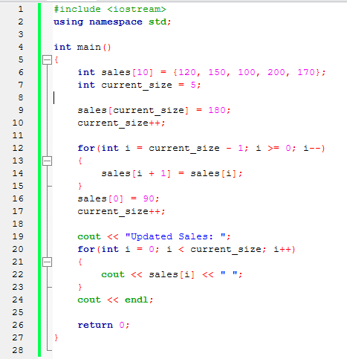

PROGRAM OUTPUT SCREENSHOT:
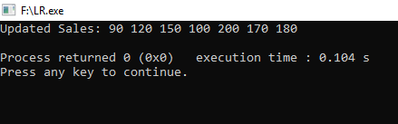

Task: 3
Problem Description:
Arrays in C++ have a fixed size, so deleting an element requires shifting all subsequent elements left to fill the gap.
In this task:
- A string array sessions[10] is initialized with 6 scheduled sessions.
- The user specifies the index of the session to cancel.
- If the index is valid, the program deletes the session and shifts remaining elements left.
- Finally, the program displays the updated schedule.
This helps students practice array indexing, element deletion, and user input handling.
PROGRAM SCREENSHOT:
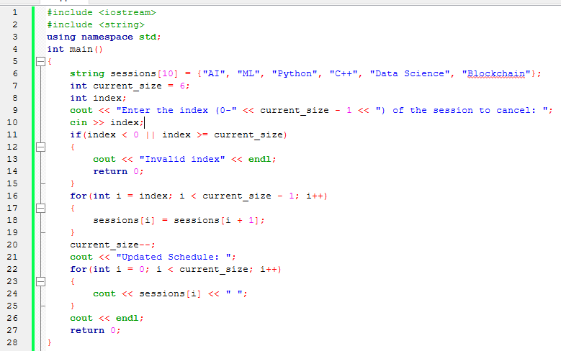

PROGRAM OUTPUT SCREENSHOT:
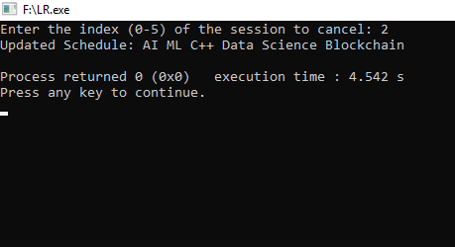
Task: 4
Problem Description:
Arrays allow storing multiple values of the same type in a single variable. Sometimes it is necessary to update an existing value at a specific index.
In this task:
- An integer array prices[5] is initialized with product prices.
- The program displays the original prices.
- The price at index 2 is updated from 150 to 180.
- The program displays the updated prices.
This demonstrates direct access and modification of array elements using indices.

PROGRAM SCREENSHOT:
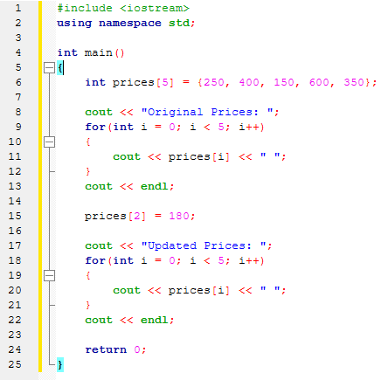

PROGRAM OUTPUT SCREENSHOT:
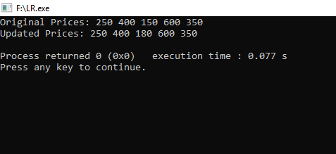
Week: 5
Task: 1
Problem Description:
Linear search is a simple searching technique that checks each element of an array sequentially until the desired value (key) is found. It works for unsorted arrays and is easy to implement.
In this task:
- An integer array marks[10] contains the marks of 10 students.
- The program asks the user to enter the marks to search.
- Using linear search, the program checks each element.
- If the marks are found, the program displays the index of the marks.
- If not found, it displays "Marks not found".
This helps students understand array traversal and conditional checking.

PROGRAM SCREENSHOT:
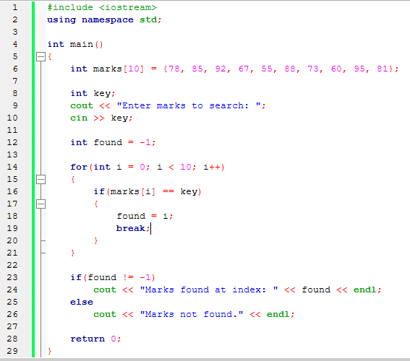

PROGRAM OUTPUT SCREENSHOT:
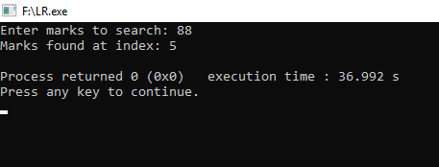

Task: 2
Problem Description:
Binary search is an efficient search algorithm that works on sorted arrays. It repeatedly divides the search space in half until the desired element is found or the search space is empty.
In this task:
- A sorted array prices[10] contains product prices.
- The program asks the user to enter the price to search.
- Using binary search, the program calculates the middle index and compares it with the key:
  - If middle element = key, the position is found.
  - If middle element < key, search in the right half.
  - If middle element > key, search in the left half.
- If the key is found, the program displays the index. Otherwise, it displays "Price not found".
This helps students understand efficient search techniques and array indexing.

PROGRAM SCREENSHOT:
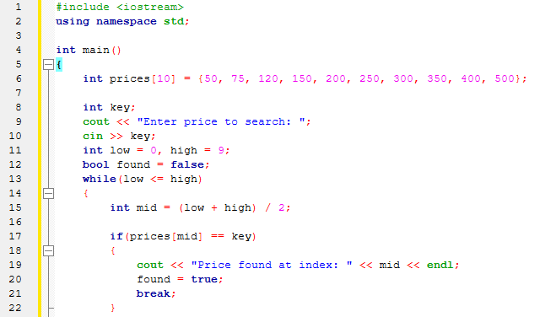
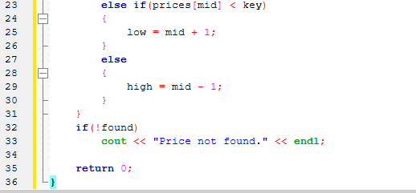

PROGRAM OUTPUT SCREENSHOT:
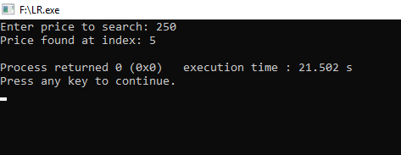

Week: 6
Task: 1
Problem Description:
A singly linked list is a dynamic data structure where each node contains data and a pointer to the next node. It is suitable for dynamic student record management, where records can be inserted at any position.
Each student record will contain:
- Student ID (integer)
- Student Name (string)
- CGPA (float)
The lab involves implementing the following functionalities:
- Insertion at beginning, end, and specific position
- Display all student records
- Count total students
- Reverse the linked list

PROGRAM SCREENSHOT:
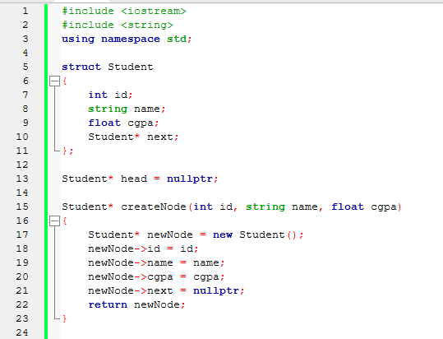
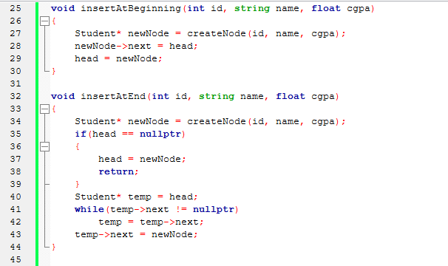
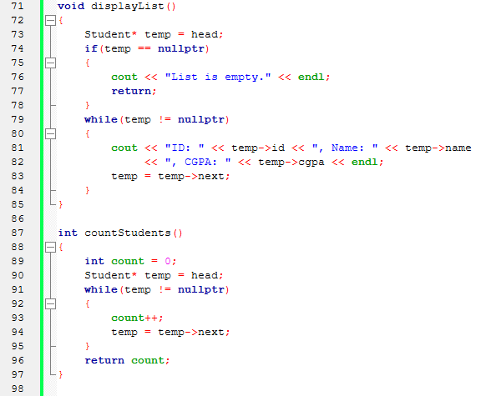
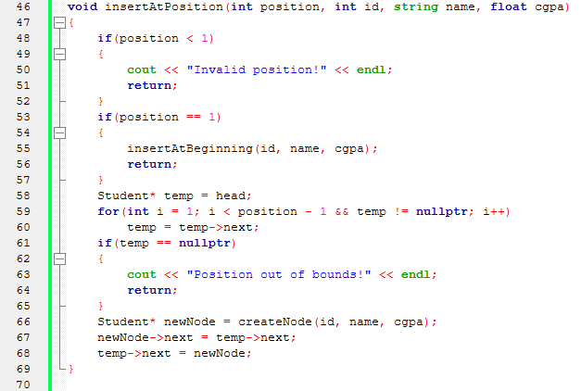

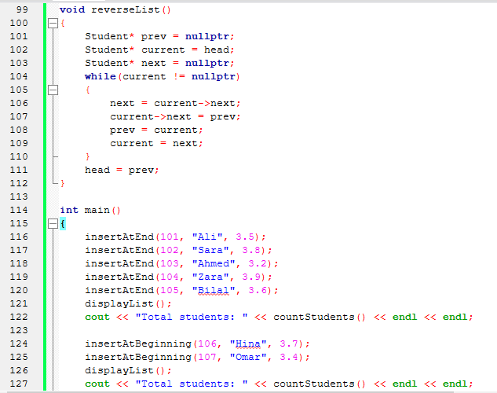
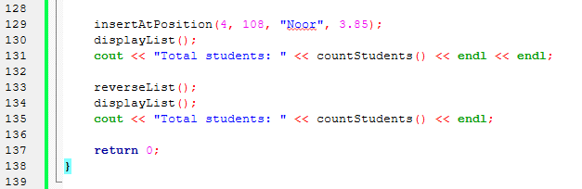

PROGRAM OUTPUT SCREENSHOT:
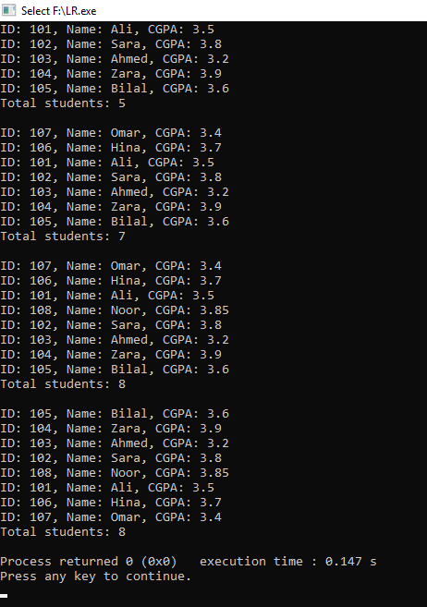

Week: 7
Task: 1
Problem Description:
You are tasked with developing a Student Management System using a singly linked list in C++. Each node in the list represents a student record and contains the following information:
- Name (string)
- Roll Number (integer)
The program should allow dynamic management of student records by performing the following operations:
- Insertion Operations
  - Insert a student at the beginning of the list.
  - Insert a student at the end of the list.
  - Insert a student at a specific position in the list.
- Deletion Operations
  - Delete a student from the beginning.
  - Delete a student from the end.
  - Delete a student from a specific position.
- Traversal / Display
  - Traverse the linked list to display all student records in the format:
Roll Number-Name
e.g., 1-Ali -> 2-Sara -> 3-Omar
- Searching
  - Search for a student by roll number.
  - If found, display the student’s name and position in the list.
  - If not found, display “Student not found.”
The system should use dynamic memory allocation (new and delete) for creating and deleting nodes. After each operation, the linked list should be displayed to verify the correctness of the operation.
Learning Outcomes:
- Understand and implement singly linked lists.
- Perform dynamic insertion and deletion of nodes.
- Traverse and display data stored in a linked list.
- Implement searching operations in a linked list.
- Gain practical experience with pointer manipulation in C++.

PROGRAM SCREENSHOT:
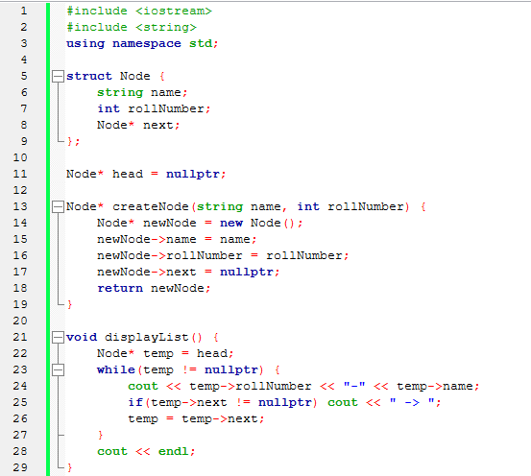

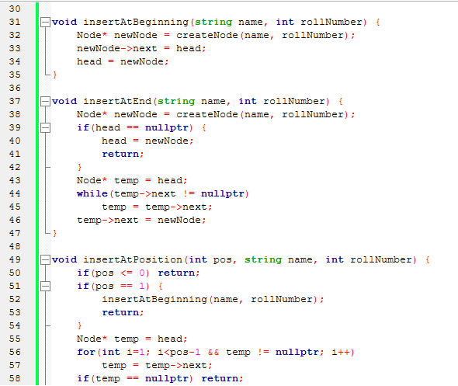

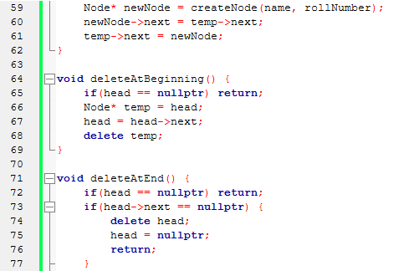

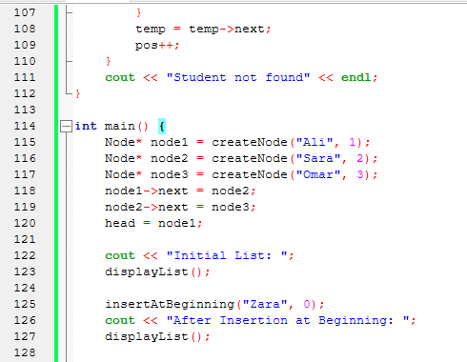
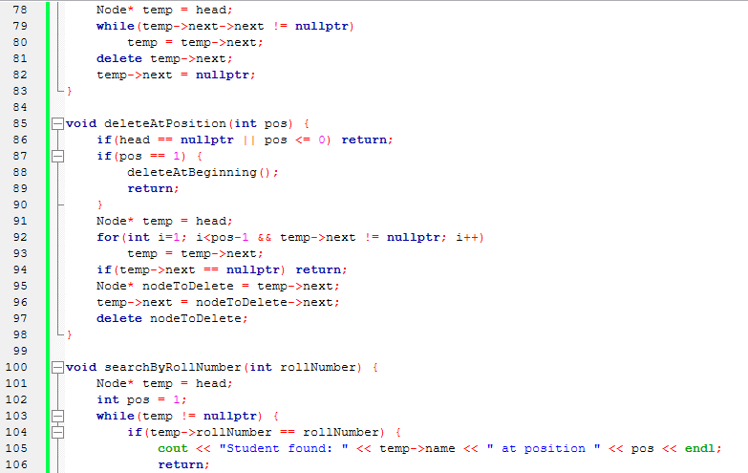

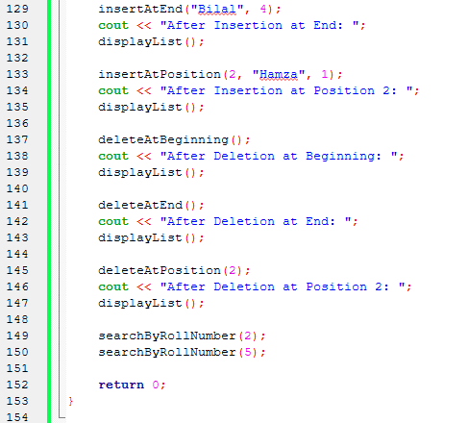

PROGRAM OUTPUT SCREENSHOT:
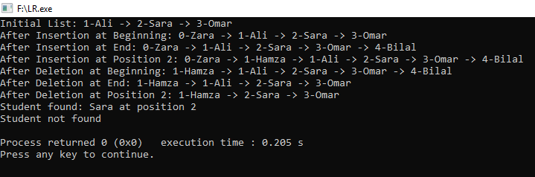

Week: 8

Task: 1
Problem Description:
In many real-world applications such as text editors, the Undo feature allows users to reverse their most recent actions. This feature works on the principle of a Stack data structure, which follows the Last in First Out (LIFO) rule. The most recent action performed by the user is the first one to be undone.
In this lab task, students are required to design and implement a Stack using a fixed-size array to simulate the Undo operation of a text editor. Each action performed by the user (such as typing text, deleting words, or formatting text) will be stored in the stack. When the user selects the Undo option, the most recently performed action will be removed from the stack.
The program should allow users to add new actions, undo the last action, view the current action, display all stored actions, and exit the program. The stack must be implemented using an array with a top pointer, and proper handling of Stack Overflow and Stack Underflow conditions must be included. The program should also be menu-driven, where each stack operation is implemented using separate functions.

PROGRAM SCREENSHOT:
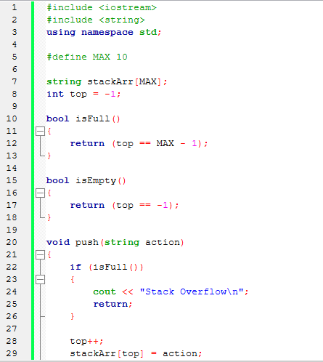
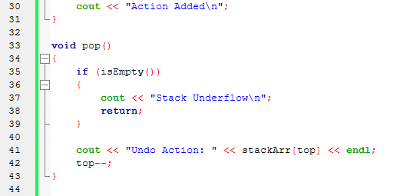
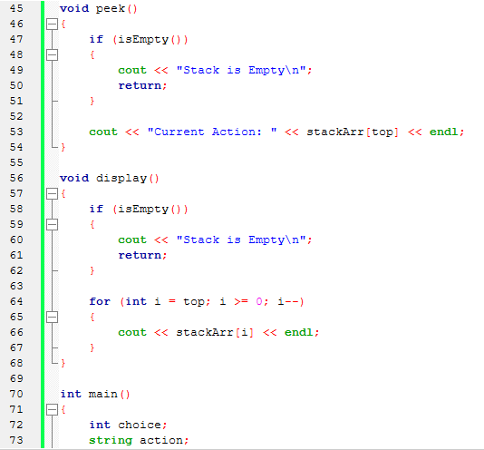
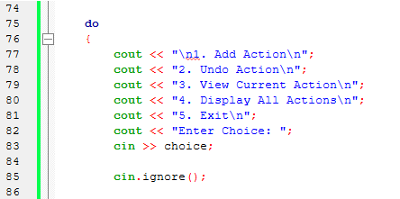

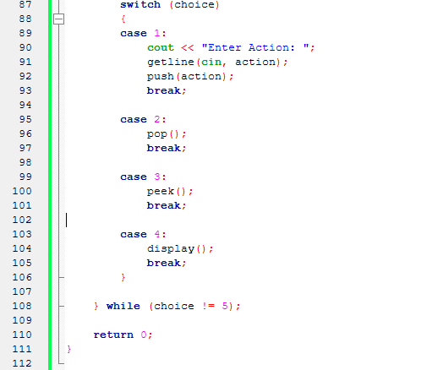
PROGRAM OUTPUT SCREENSHOT:
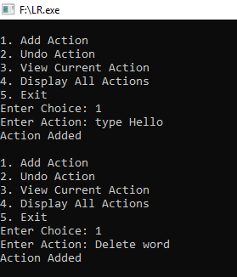
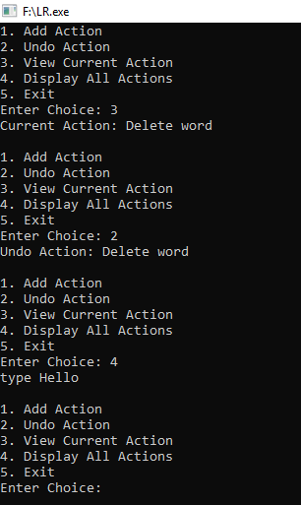
Task: 2
Problem Description:
Modern web browsers provide a Back button that allows users to return to previously visited web pages. This functionality can be efficiently implemented using a Stack data structure, which follows the Last in First Out (LIFO) principle. The most recently visited webpage is the first one removed when the user presses the Back button.
In this lab task, students are required to design and implement a Stack using a Linked List to simulate the Browser Back feature. Each time a user visits a new webpage, the page is pushed onto the stack. When the user selects the Back option, the current page is popped from the stack, and the browser returns to the previous page.
The program should allow users to visit new pages, go back to the previous page, view the current page, and display the complete browsing history. The stack must be implemented using a linked list with dynamic memory allocation, without using arrays or the STL stack. The program should also ensure that memory is properly freed during the pop operation and must be menu-driven, with separate functions for each stack operation.

PROGRAM SCREENSHOT:
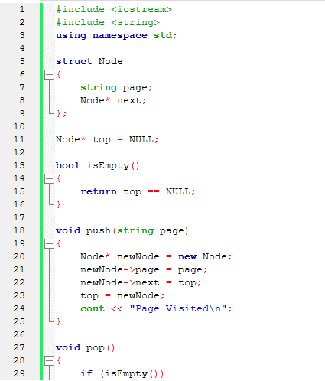

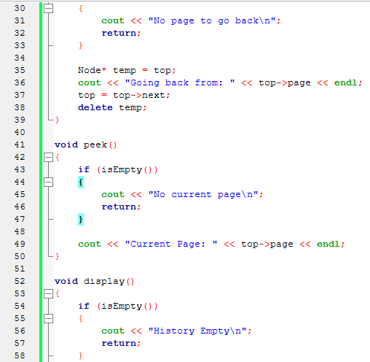
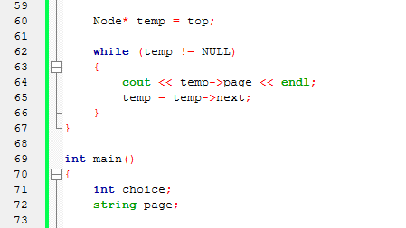

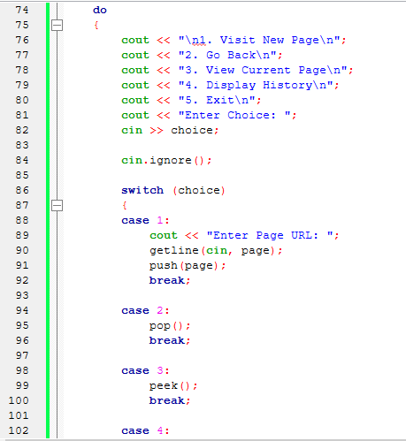
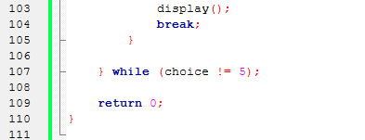

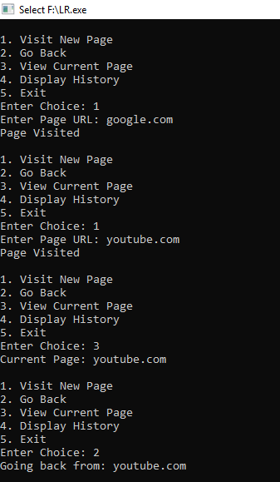
PROGRAM OUTPUT SCREENSHOT:

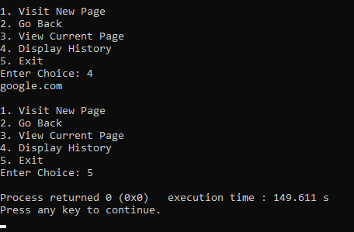

Week: 10

Task: 1
Problem Description:
A Queue is a linear data structure that follows the First in First Out (FIFO) principle, where the element inserted first is the one that is removed first. In many applications, a Circular Queue is used to efficiently utilize memory by connecting the last position of the queue back to the first position, forming a circular structure.
In this lab task, students are required to implement a Circular Queue program that takes user input for enqueue and dequeue operations. The program should allow users to insert elements into the queue, remove elements from the queue, and display the current elements stored in the queue.
The program must be menu-driven, allowing the user to repeatedly select different operations such as enqueue, dequeue, display, and exit. Students will also convert the array-based circular queue into a linked-list-based circular queue, where nodes are dynamically created and connected in a circular manner.
Additionally, students must perform dry runs with different test cases to verify that the circular queue works correctly, including checking conditions such as queue empty and queue full, and ensuring that the front and rear pointers move correctly in a circular manner.

PROGRAM SCREENSHOT:
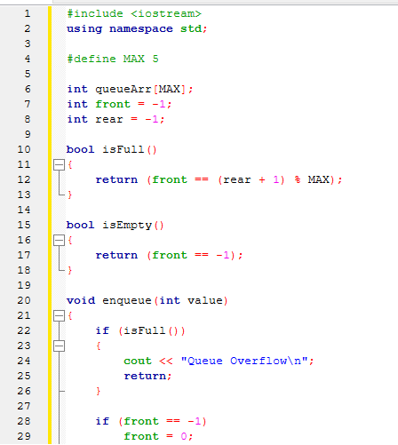
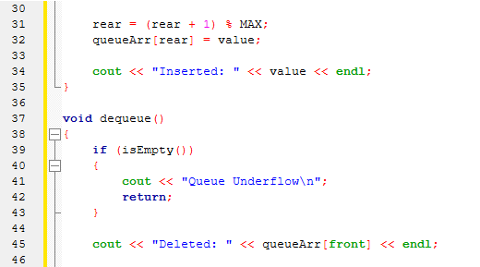
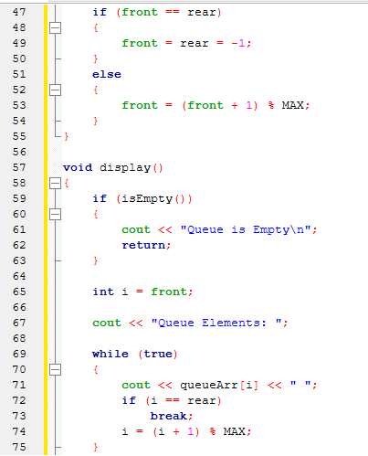
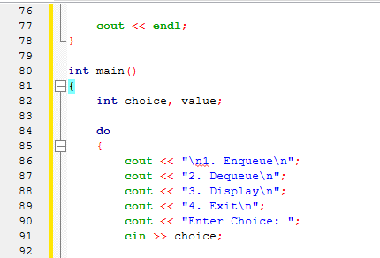

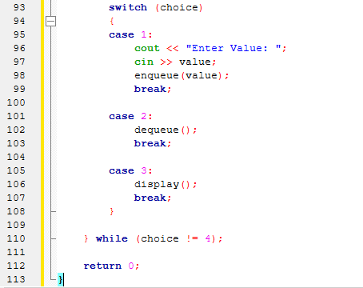
PROGRAM OUTPUT SCREENSHOT:
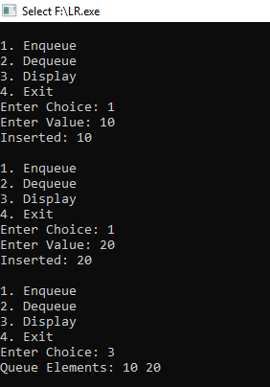
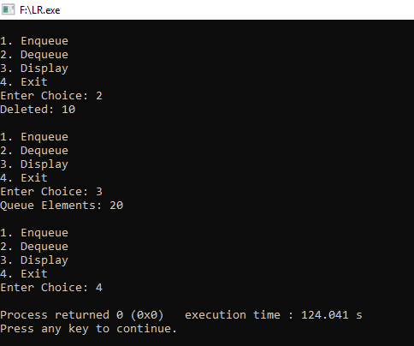

Week: 11

Task: 1
Problem Description:
A Deque (Double Ended Queue) is a linear data structure in which insertion and deletion operations can be performed from both ends, i.e., the front and the rear. Unlike a simple queue where insertion occurs at the rear and deletion at the front, a deque allows more flexibility by supporting operations at both ends.
In this lab task, students are required to implement a menu-driven Deque program that allows the user to perform different operations such as inserting elements at the front or rear and deleting elements from the front or rear. The program should take user input for the values to be inserted into the deque.
The implementation should also properly handle edge cases, such as overflow (when the deque is full) and underflow (when the deque is empty). Students should test these conditions to ensure the correctness of the program. The program should display a menu repeatedly so that the user can choose different operations until the exit option is selected.

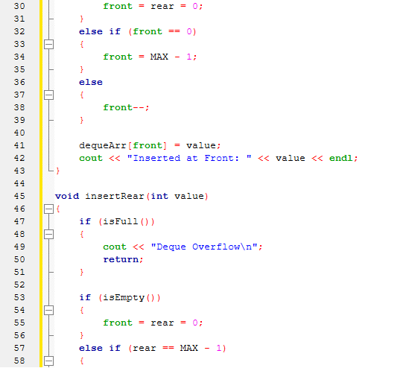
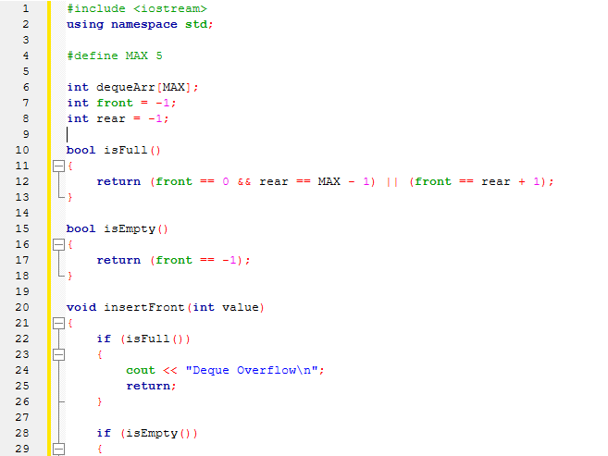
PROGRAM SCREENSHOT:

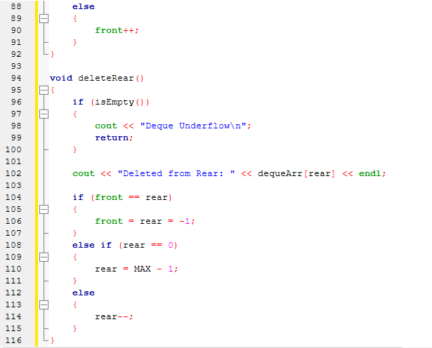
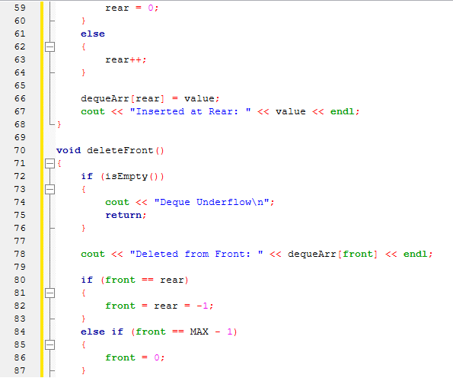
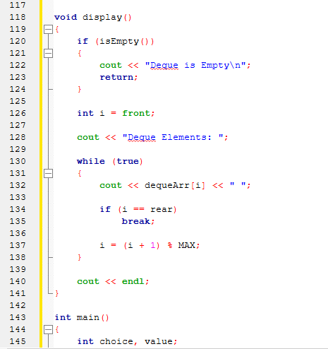

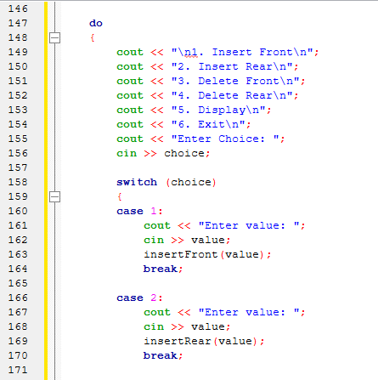

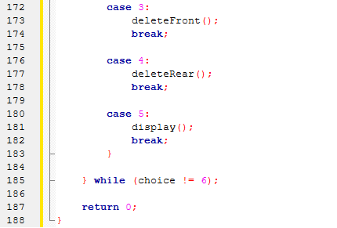
PROGRAM OUTPUT SCREENSHOT:
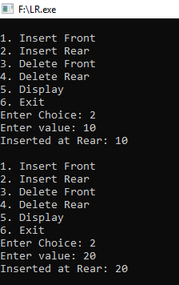

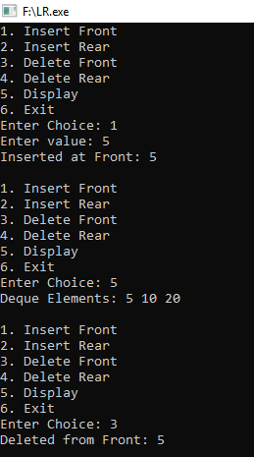

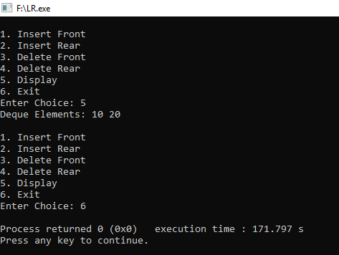

Week: 12
Task:
Problem Description:
A priority queue is a special type of queue in which each element is associated with a priority value. Elements are served based on their priority instead of their insertion order. The element with the lowest priority value is removed first.
In this lab task, develop a menu-driven C++ program that implements a priority queue using a heap (min-heap). The program should allow the user to insert elements with priorities, display the queue, and delete the element with the lowest priority.
Operations to Implement
- Insert element with priority (user input)
- Delete element with lowest priority
- Display priority queue
- Exit program

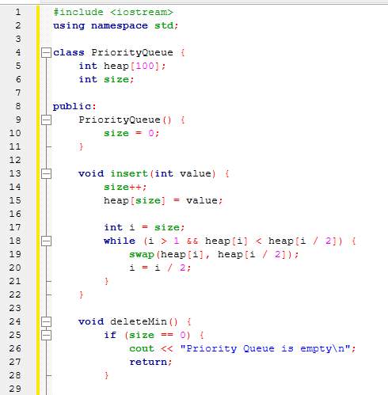
ROGRAM SCREENSHOT:

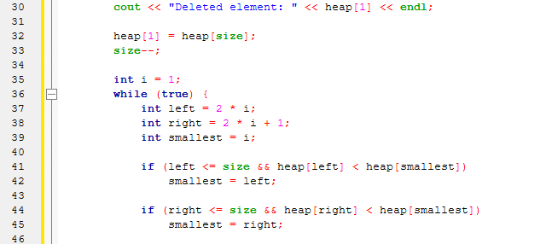

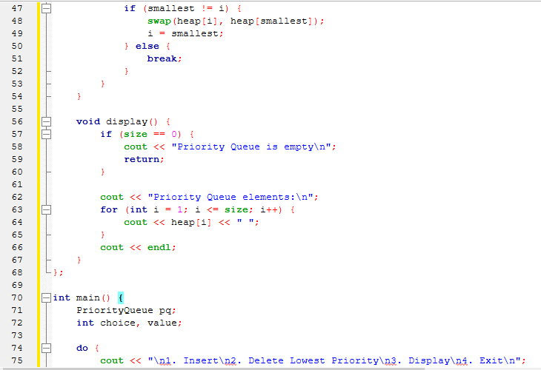

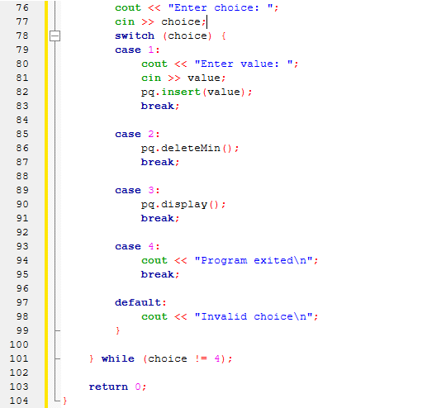
SCREENSHOT:

